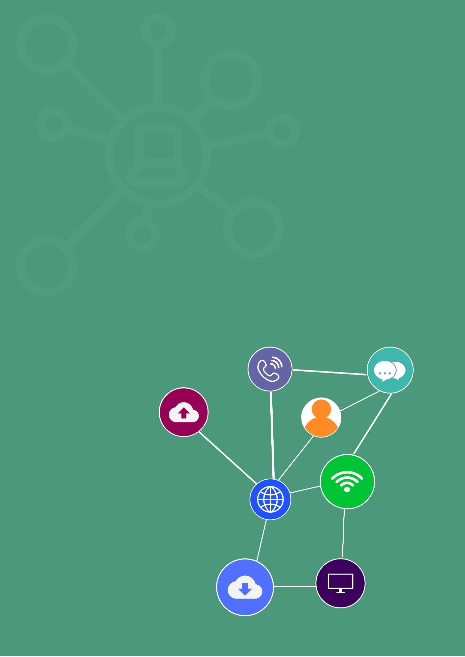

**student guide**

**Research and apply emerging web technology trends**

**ICTWEB527 Research and apply emerging web technology trends**

CONTENTS

Overview 3

Topic 1: Emerging web technologies 4

Topic 2: Implementing new technologies 16

Overview

Application of the unit

This unit describes the skills and knowledge required to identify, research and apply emerging web technologies.

It applies to individuals who are highly skilled technicians and have high-level knowledge of the principles of analysis and design.

No licensing, legislative or certification requirements apply to this unit at the time of publication.

Learning goals

Learning goals include:

* identifying emerging web technology
* implementing new web technology
* reviewing and finalising web technology implementation process.

Topic 1: Emerging web technologies

Introduction

The term web technology refers to the software used for web design and development for communication across the Internet of Things. It is the interface between any web connected device such as a computer, phone, tablet, wearable, television etc., and another device connected to the internet such as a web server, file service or computer.

Web applications

Consider the fact that when using a program on a computer, it may have to be configured to fit the requirements of different operating systems. That’s when a web-based application can be a valuable tool for an organisation, since it is accessible on any device. It runs on a web server and accessed by the user via a web browser and internet connection. Web-based applications include all the applications that communicate with a user via HTTP.

These programs are accessed online, some examples of web-based applications include:

* word processing and spreadsheets
* online forms
* email programs
* shopping carts
* online payment systems
* interactive internet portals.

Web based programs have a lot of advantages:

|  |  |
| --- | --- |
| **Head with gears** | **Activity: Practical** |
| Look up the following calculator for exchange rates:  [www.xe.com](http://www.xe.com)  Enter in an amount in dollars and see the conversion for 2 different countries of your choice.  This is a web application in action!  Your trainer will facilitate a discussion about the outcomes from the activity. |

So, why do you need to research emerging web technology trends? Broadly, it is so that you can implement the most up to date technologies and standards to cope with security, legislative requirements, organisational requirements and to be on top of what is current for future needs.

Identifying the needs of the web application can help to ascertain the features and functions that you need to incorporate into the software development.

* What do you want the web application to do?
* What features and functions are required to make this happen?

Every web application will have different functionality requirements, that will be specific to the project brief or client requirements. For example, the type of interactions required, how they will be performed and stored and presented to the user such as an online form, shopping cart or email program.

|  |  |
| --- | --- |
| **Head with gears** | **Activity: Research and discuss** |
| Research the following web applications, outlining what the web application is used for (requirements) and at a function and feature of each one.   |  |  |  |  | | --- | --- | --- | --- | | **Web application** | **What is the application used for?** | **Features** | **Functionality** | | Online form |  |  |  | | Shopping cart |  |  |  | | Calculator (for example exchange rates) |  |  |  | |

Legislative and organisational requirements

There are a number of legislative requirements that are associated with web application development that a software developer will need to comply with. This is due to the need for protection of the design, development and coding of web development as well as agreements made for online selling and relates to the following:

* Legal requirements for operating an ecommerce site.
* Privacy and confidentiality.
* Copyright, Intellectual property and trademark.
* Meeting terms and conditions.
* Australian consumer laws.
* Implementing cyber security to protect your client.

*Image by* [*Matthias Zomer*](https://www.pexels.com/@matthiaszomer) *on* [*Pexels*](https://www.pexels.com/photo/person-signing-document-paper-618158/)

|  |  |
| --- | --- |
| **Head with gears** | **Activity: Read** |
| Further information of legislation relating to web development:  <https://legal123.com.au/how-to-guide/legal-guide-web-developers/>  Information on website development and the law:  <https://www.artslaw.com.au/information-sheet/website-development/> |

|  |  |
| --- | --- |
| **Head with gears** | **Activity: Watch** |
| Watch the following video that explains the legal issues involved in developing a web application.  Website and video: <https://legal123.com.au/how-to-guide/how-to-develop-an-app-infographic/> (06:27) |

The organisational requirements, standards and procedures that a web developer follows will be dependent upon who you work for. The following are some general requirements:

|  |
| --- |
| **Following a software development lifecycle such as SDLC for web development** |
| A methodology adopted for the design and development of software projects. The methodology provides clearly defined steps and processes from the beginning to the end of a project. The process is meant to produce software with the highest quality and lowest cost in the shortest time. It includes a detailed plan on how to develop alter maintain and/or replace a software system. The SDLC can be roughly followed to achieve best practices in software design and development. |
| Work through the tutorial to develop your understanding:  <https://www.guru99.com/software-development-life-cycle-tutorial.html> |
| **Word Wide Web Consortium (W3C) Standards** |
| * W3C develop the standards for the world wide web. * Complying with web standards can provide accessibility to software/machines and people, along with providing stability, consistency and compatibility. |
| The following link to their web design and applications standard page provides a number of further links for HTML & CSS and Accessibility:  <https://www.w3.org/standards/webdesign/>. |
| **Accessibility** |
| When designing and creating web pages, it is important that they are accessible to everyone. It should allow a user to navigate and interact with a site easily. The code must be as semantic as possible (using the correct HTML elements for their correct purpose) so that it is easy to understand for other users or screen readers.  In particular, due to the visual and dynamic nature of webpages, it is important to make sure that the website will also make sense to visually-impaired or blind users. |
| Read the following information from W3schools explaining HTML accessibility:  <https://www.w3schools.com/html/html_accessibility.asp> |
| **Following rules and standards for website design and functionality** |
| For example:   * Easy navigation * Customisable * Site navigation made easy for the user * Ability to work on multiple browsers and devices * Consistency * Quick load time * Embedded privacy and security |
| **Using standard organisational software development processes** |
| * Such as the waterfall model following the software development life cycle phases. * Standards for coding. * Organisational software development practices. * Templates, documentation and styles to provide consistency and standard practices. |
| **Following coding standards for web applications** |
| * Syntax and algorithm standards. * Structure of code and commenting. |

Research and review new developments in web technology

Firstly, let’s look at the principles of the internet and technologies that underpin its existence.

The internet is the hardware used to connect multiple computer networks. A network of interconnected computers.

Looking further, the internet comprises broadly of the following:

|  |  |
| --- | --- |
| **Head with gears** | **Activity: Watch** |
| Introduction to computers: Technologies on the internet.  Video: <https://www.youtube.com/watch?v=tcvutchrZBs> (16:13) |

|  |  |
| --- | --- |
| **Head with gears** | **Activity: Read** |
| Internet Protocol Stack:  <https://www.w3.org/People/Frystyk/thesis/TcpIp.html>  Take any notes to summarise what you have read and keep for future reference. |

With the speed of emerging technologies and trends, the way in which web applications are designed and developed has evolved and grown. Furthermore, web development is not limited to just building websites. It includes for example creating web browsers and plugins, games and E-commerce.

The current web technology trends that are affecting web development are:

Current web technologies can be divided into the following components:

|  |
| --- |
| **Mark-up languages** |
| * HTML5 * CSS * XML * HTTP |

|  |  |
| --- | --- |
| **Programming languages and technologies** | |
| * Visual Basic * .NET * Perl * C (sharp) * Java | * Python * Ruby on Rails * PHP * JavaScript |
| **Web server and technologies** | |
| * Apache * Microsoft IIS * Nginx * NetWare server * Google Web Server | |
| **Databases** | |
| * MySQL * Microsoft SQL * Postgre SQL * Oracle | |
| **Applications** | |
| * Social networks * Email * Mobile apps | |
| **Frameworks** | |
| * Backend frameworks such as Rails, Django * Frontend frameworks such as Angular, Vue.js and React (more a frontend library) | |

|  |  |
| --- | --- |
| **Head with gears** | **Activity: Read** |
| A guide to server technology:  <https://www.upwork.com/hiring/development/a-guide-to-server-technology/> |

New developments in web technology is present in a number of platforms, for example:

* Cloud services
* Social networks
* Collaboration sites such wikis
* Learning moodles
* Email
* Web browsers
* Streaming videos, podcasts
* Mobile devices
* Online messaging
* Online gaming.

Keeping up to date with current technological developments means looking at the opportunities, risks, benefits and limitations.

What was current and popular in web development in 2016 is very different to what is emerging in 2021.

In just five years there has been a rise in AI, machine learning and use of chatbots and web development changes in the code being used, frameworks and environments.

Finding information about new technologies and keeping up to date with current trends can be through:

* social network sites such as LinkedIn, Twitter or Facebook
* following blogs, journals or subscribing to industry bodies or professional organisations.
* researching on the internet for news, or subscribing to newsletters/RSS
* subscribing to podcasts
* using forums
* attending workshops, conferences and events
* undertaking free online courses.

*Image by* [*Kaboompics .com*](https://www.pexels.com/@kaboompics) *on* [*Pexels*](https://www.pexels.com/photo/women-typing-on-the-notebook-6168/)

|  |  |
| --- | --- |
| Head with gears | **Activity: Group work** |
| Divide into small groups. Ensure you divide the work equally.  Your group is to present information to a client on the following:   * The latest web technology trends and their application. * An evaluation of a web application using current trends in web technology. * Where to find information on new and emerging, trends and technologies.   The focus must be on one area, selected and researched by the group. For example, Progressive Web Apps or Chatbots.  The information should be presented in a clearly structured and professional manner, as if to a client who has little knowledge of the topic. The presentation should be visually appealing with transitions, animations and consistent styles and colours.  During the presentation you must demonstrate effective communication skills including:   * Speaking clearly and concisely * Using non-verbal communication to assist with understanding * Asking questions to identify required information * Responding to questions as required * Using active listening techniques to confirm understanding   Each person in the group must contribute equally to the design, development of the presentation and also each member must take part in the delivery.  Your trainer will observe you conducting the presentation, ask questions at the end and provide feedback on the information presented and the presentation style, as well as the content.  Submit all work as professionally written documents within the timeframe allocated. Your trainer will provide your group with feedback. |

Identifying web technology to meet the needs of web applications

Using the most appropriate web technology will require evaluating some factors such as:

Selecting the technology will be largely dependent on its ability to carry out the desired function and may also be dependent upon the preferences, skills and knowledge of the developers.

Web development consists of:

* client-side development using a mark-up language and programming language.
* server-side development using programming languages, a database and server.

In order to develop a web application, you need to select a server, a database, a programming language, a framework and front end tools.

|  |  |
| --- | --- |
| **Head with gears** | **Activity: Watch** |
| Basic concepts of web applications, how they work and the HTTP protocol.  Video: <https://www.youtube.com/watch?v=RsQ1tFLwldY> (07:46) |

|  |  |
| --- | --- |
| **Head with gears** | **Activity: Report** |
| Divide into pairs. Allocate the work evenly.  You have been asked by a client to identify the most appropriate web technology that will enable a user to ask questions and gain feedback using a chatbot.  The idea is to provide customers with immediate online support, upon request.  Review the following information from the Chatbot learning centre:  <https://www.drift.com/learn/chatbot/>   * You must select a web technology that you have the skills, knowledge and ability to use as you will need to generate the code in the next topic. It must also me the most applicable to web application needs. * List the features and functions.   The evaluation must include justifiable reasons for the selection. You must clearly outline assumptions.   * What legislation would be applicable to the implementation of the technology? * List four organisational requirements and standards that may also apply.   Your report should be between 1–2 pages long and be written in clear and concise English.  Submit your report to your trainer for feedback. |
|  |

Confirming and negotiating selected technology

Once you have completed research on new developments in web technology that will meet the identified needs of the web application being developed and conducted an evaluation to select the most applicable for the requirements you have been given, the next step will be to discuss and confirm the selection with the most relevant people. This could be the client, software developers or the project manager.

In your role as a technician, you will have a high level knowledge of the aspects for the capabilities, efficiencies and effectiveness of the web technologies identified to be implemented.

It will therefore be up to you to discuss and confirm this with the right people. You may need to negotiate with the project team or the client, to ensure that what you have identified can be used. This may be due to the fact that they do not understand how the software works and why it has been chosen.

Topic 2: Implementing new technologies

Creating the code

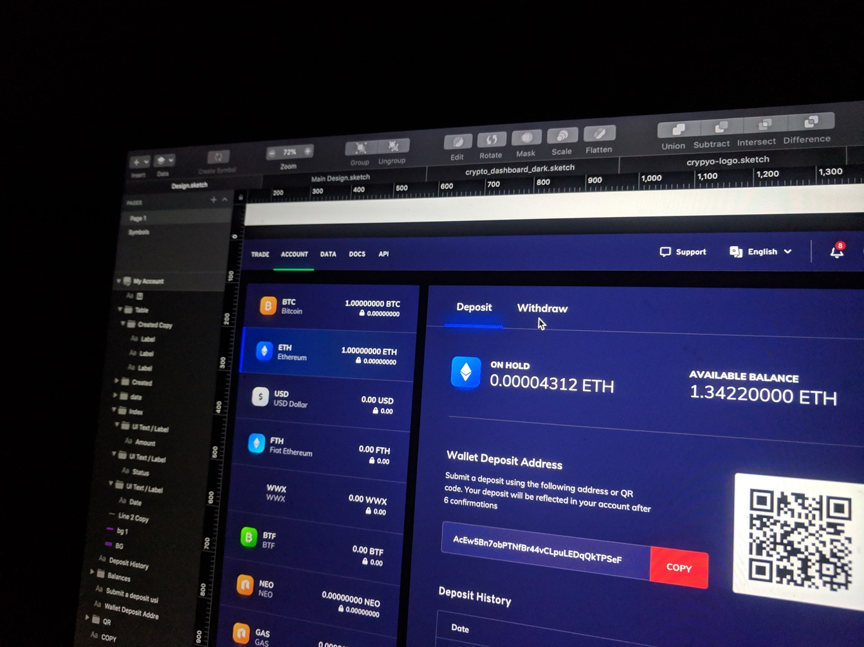The implementation of new web technology will be solely dependent upon the need, the client requirements and the objectives of the web application.

Creating the code is one part of web development and the approach taken will be reliant on the available resources, any current web applications developed, the skill and knowledge of the developers and the hardware and software available.

*Image by*[*Eftakher Alam*](https://unsplash.com/@easiblu?utm_source=unsplash&utm_medium=referral&utm_content=creditCopyText)*on*[*Unsplash*](https://unsplash.com/s/photos/web-apps?utm_source=unsplash&utm_medium=referral&utm_content=creditCopyText)

Principles of analysis and design

Before creating the code for the web application, it is important to understand the principles of analysis and design as well as programming concepts.

Analysis is the first stage of any project and is the process of gathering information to ascertain the purpose, goals and objectives as well as the audience and how the business will benefit. In other words, it’s an investigation of a problem and requirements, specifically addressing what the client wants.

The principles of analysis include:

* gathering requirements
* identifying the purpose
* determining goals and objectives
* identifying the audience
* documentation
* communication
* planning.

Effective web application design is judged by the users of the website, not the people running it. Many factors affect the usability of a website, not just form (how good it looks), but also function (ease of use).

Websites that are not well designed tend to perform poorly and will usually have sub-optimal Google Analytics metrics such as low time on site, high bounce rates, low pages per visit and low conversions.

Below are some general web application development principles current and relevant in today’s industry:

Programming control structures

Program control is how a program organises its activities and makes decisions. This involves executing particular code based on a user input or the outcome of a prior operation.

The flow of control through any given function is implemented through three basic types of control structures:

|  |
| --- |
| **Sequential: default mode** |
| Sequential execution of code statements, one line after another is like following a recipe. |
| **Selection** |
| Used for decisions, branching, which is choosing between 2 or more alternative paths. In C++, these are the following types of selection statements:   * IF * IF/ELSE * SWITCH |

|  |
| --- |
| **Repetition** |
| Used for looping, which is repetition of a piece of code multiple times in a row. In C++, there are the following three types of loops:  WHILE  DO/WHILE  FOR |

Programming design structure

There is a standard way of organising the component structure, data structure, and control structure for a single-user application (used by one person at a time), which normally reads data, saves it in a data structure, computes on the data, and writes the results. This is the following:

|  |
| --- |
| Design the program's component structure with three components. This must be organised in a model-view-controller pattern. |
|  |
| Decide what form of data structure (array, table, set, list, tree, etc.) the program's data will be held with. The data structure will be inserted into the program's model component. |
|  |
| Write the algorithm that defines the execution steps: which is the control structure. The algorithm will then be placed inside the program's controller. |
|  |
| Determine the form of input and output (disk file, typed text in a command window, dialogs, a graphical-user interface, etc.) that the program uses. This will be embedded in the program's view. |

Object-Oriented Programming (OOP)

OOP is a programming paradigm based on the concept of class and objects rather than functions and logic. It is used for large complex programs that are actively updated or maintained, such as a web application.

So object-oriented programming is a coding technique constructed around objects rather than procedures, and these objects can work with each other. Attributes and behaviours can be given to the objects. This means that developers can then focus on programming how the objects work with each other. OOP consists of:

* objects
* class
* inheritance
* interface
* package.

Object-Oriented Programming Languages:

* Java
* Python
* Ruby
* C++
* Smalltalk
* Visual Basic .NET
* Objective-C.

|  |  |
| --- | --- |
| **Head with gears** | **Activity: Read and watch** |
| Object-oriented programming concepts.  Article: <https://docs.oracle.com/javase/tutorial/java/concepts/>  The following clip explains the four pillars of object-oriented programming.  Video: <https://www.youtube.com/watch?v=pTB0EiLXUC8> (07:00) |

Web programming concepts

When creating code there are a number of web programming concepts that you will apply:

* Authentication and web security

Web server security protects information assets that can be accessed from a Web server. It is important for anyone who has a physical or virtual web server that is connected to the Internet. It requires defence that has several layers.

* Hypertext transfer protocol (HTTP)

Hypertext Transfer Protocol (HTTP) is an application-layer protocol for transmitting hypermedia documents, for example HTML. It was originally designed for communication between web browsers and web servers, but it is also used for other purposes. HTTP follows a standard client-server model: the client opens a connection to make a request, then waits until a response is received. HTTP is a stateless protocol, which means that the server does not keep any data (state) between two requests.

* Stateless programming

With stateless programming the operations that are implemented are not sensitive to the state of the computation. All the data used in an operation are passed as inputs to the operation, and all the data used by whatever operations invoked that operation is passed back as outputs. The program must have Value semantics as it is not permitted to modify shared/aliased data structures, and objects do not have an identity. They must not use global or class variables, and all of the input s and outputs must be handled specially, through monads or by threading an I/O state through any parts of the computation that perform I/O.

* Session management

A web session is a sequence of network HTTP request and response transactions that are associated to the same user. Complex web applications require that information or status about each user is retained for the duration of multiple requests. Sessions provide the ability to establish variables, such as localization settings and access rights, which apply to every interaction the user has with the web application for the duration of that session.

Web applications can create sessions to keep track of anonymous users after the first user request, such as the user language preference. Web applications will make use of sessions once the user has authenticated, which ensures the ability to identify the user on any subsequent requests. They make it possible to apply security access controls and authorised access to the user private data. Current web applications can provide session capabilities both prior to, and following, authentication.

* Client-side programming

Client-side scripting is the code put into a standard HTML page and processed through the client to produce the output. The code can be viewed via code view window and a browser.

Client-side webpages can only contain client-side scripting for developing web pages.

* Server side programming

Server-side scripting is the code put into a server-side webpage such as a PHP page. The web browser will request a certain webpage and the page is then processed on the web server using an interpreter and then supplies data, images or any other code and merges it with your code that has been inserted within your web design of either CSS or HTML to produce the finished page.

Server-side code can’t be viewed because the code is executed on the server and then delivered as HTML to the client.

Applying the code

After developing the code, you will need to apply it to the web technology being used. This is part of testing that the code works and the way in which it is applied will be dependent upon the platform and programming language being used.

When implementing code, you may also need to follow organisational procedures such as the way in which the code is embedded or naming conventions. You may need to follow a software development lifecycle process and have specific procedures to follow.

|  |  |
| --- | --- |
| **Head with gears** | **Activity: Practical** |
| This time should be allocated to learning or developing code that can be used for your web application. This will be dependent upon the code you are learning to apply the chosen web technology.  Demonstrate that you can create the code and submit or have this observed by the trainer/assessor for feedback.  The trainer/assessor will support you during this process. |

Testing

Testing is a major aspect of implementing web applications and usually done whilst being developed. Testing a web application can include:

* Functionality Testing
* Usability testing
* Interface testing
* Compatibility testing
* Performance testing
* Security testing.

Validation

Validation is an important step to ensuring the technical quality of web pages. W3C validation is the process of checking a websites code to determine if it follows the formatting standards. If you fail to validate the pages of your website based on W3C standards, your website will most likely suffer from errors or poor traffic owing to poor formatting and readability. This is also part of testing.

Reasons to test a web application:

* Ensures code is properly formatted.
* Browser compatibility.
* Device compatibility.
* Teaches best practices in design.
* Improves user experiences.
* Used as a debugging tool.

Browser compatibility

Compatibility with other browsers is a very important testing aspect.

* Some applications are very dependent on browsers. Different browsers have different configurations and settings that your web page should be compatible with.
* Your website coding should be a cross-browser platform compatible. If you are using java scripts or AJAX calls for UI functionality, performing security checks or validations then give more stress on browser compatibility testing of your web application.
* Test web application on different browsers like Internet Explorer, Firefox, Netscape Navigator, AOL, Safari, Opera browsers with different versions.

Any issues that you have can then be identified and rectified to ensure that the web application is usable on all devices and browsers.

Testing components

Testing can be for front end elements (i.e., content, links) and back end elements (database and functions used in the code).

The testing therefore will finally include the interaction between these two elements.

Testing code is a continual and cyclic process that occurs both as the programmer is coding and also to finalise sections of code and then finally interacting with the front end development.

A component test can include:

* whether a search function works
* if a shopping cart works
* database query.

Component testing tests each component in isolation (also known as module or program testing).

When the component is tested, sample data is used to validate, using various testing variables, upper and lower limits, and ranges.

|  |  |
| --- | --- |
| **Head with gears** | **Activity: Practical** |
| Copy the URL from any website and perform a cross browser testing using the following site:  <https://www.browserling.com>  Use the validation service website to validate the URL:  <https://validator.w3.org> |

|  |  |
| --- | --- |
| **Head with gears** | **Activity: Practical** |
| This time should be allocated to testing and validating the code that has been developed in the previous task.   * Run a number of tests to ensure that the code works. * Test on at least three different browsers. * Document the testing using screen shots or recordings. Make a note of each test that you undertake, the expected outcome and the actual outcome. * Use the validator service to check your code. Keep a screen shot or copy of the results.   Include as a testing report, in a professionally typed document. |

Rectifying problems

Testing the web application on different browsers can identify any problems or issues with the code and compatibility. Using the validator is also a good way for checking the validity of the code, which may also affect the way it works with different browsers.

The results from the testing will outline or flag any issues. You can then make any necessary changes to the code and then re-run the tests until there are no errors.

|  |  |
| --- | --- |
| **Head with gears** | **Activity: Read** |
| Introduction to cross browser testing:  <https://developer.mozilla.org/en-US/docs/Learn/Tools_and_testing/Cross_browser_testing/Introduction>  Take any notes to summarise what you have read and keep for future reference. |

|  |  |
| --- | --- |
| **Head with gears** | **Activity: Practical** |
| This time should be allocated to rectifying any issues with the code that has been tested in the previous task.  Once you have made any modifications then re-run the tests. Keep a record of the second testing and of the results.  When you are happy that there are no errors, include in your testing report and submit to your assessor trainer/assessor for feedback. |

Reviewing results

Finally, after the development and testing of the code you will need to review the results and discuss any findings with the relevant project team members, project manager or client and any other required personnel.

Keeping track of the tests can provide evidence and records that can be used to review the outcome of the web application testing.

You may find that the code implemented requires further development or the testing has found issues such as browser or device incompatibility.

Seeking feedback is an important part of completing the testing, it allows you to determine any issues or can also be a way of consulting and brainstorming with the development team to rectify problems and solve issues.

Documentation

Once testing and validation is complete then all the documentation should be reviewed and approved for sign off.

There will be a wide range of documentation created during the development of a web application.

Documentation during development should also be kept up to date with any changes or deviations from the original documents.

This can be done using a standard framework, version control, notes and comments in code, along with messages, emails or progress reports. The post-development documentation is produced to support the developers of the site and provide manuals and training material for the end users if required (for example how to use the server software). It will also include testing plans, documentation, user interface changes, end-user documentation, and lesson’s learned reporting.